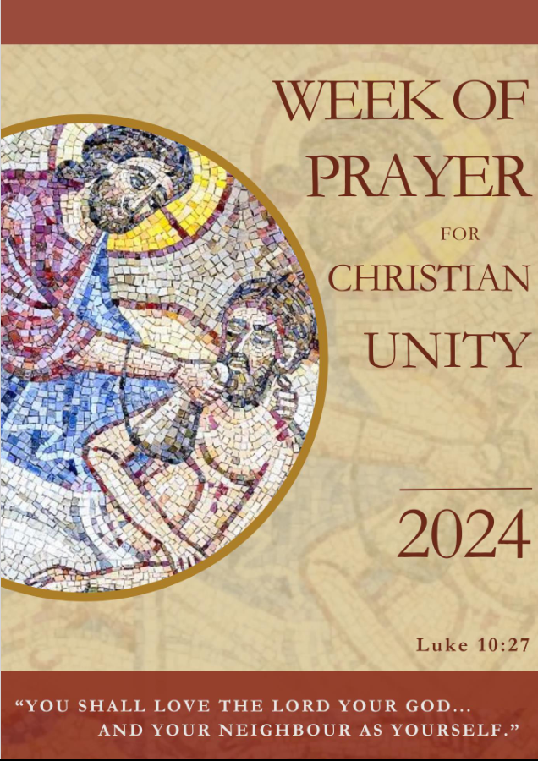

Order of Worship

Gathering and Sharing God’s Love

R: In Burkina Faso, a calabash is used to share water with guests who arrive tired from their journey. It expresses welcome, hospitality and fellowship. After the visitor has been refreshed, conversation can begin and the purpose of the visit can be expressed.

As we gather and enter into prayer, we welcome you in the same way as Abraham welcomed the three visitors and provided water for their refreshment. We invite you to be refreshed by sharing the water from this calabash.

Water from the calabash is shared by a member of the host community with representatives of the other churches present. As the calabash is being returned to the front of the sanctuary, worship leaders join in the procession while a hymn is sung or music is played.

Invitation to Pray

L: In the name of the Father and of the Son and of the Holy Spirit.

A: Amen.

L: We are gathered as brothers and sisters to pray for the visible unity of Christians. At the heart of our worship is the story of the Good Samaritan where we hear the divine call to love God and to love our neighbour as ourselves.

Let us prepare to meet the God of Love in thanksgiving and joy, remembering his command to love.

A: Glory to you, Father,
for you reveal yourself in your creation
and call all people to live in your presence.
Glory to you, Christ Jesus,
for you give yourself entirely to each one of us
and invite us to do the same.
Glory to you, Holy Spirit,
for you gather us together in love and unity.
Glory to you, God of Love,
in whom we are created, redeemed and made one.
Amen.

Hymn

Litany of Praise and Thanksgiving

R: Let us turn our hearts to God in praise:

Praise to you Lord for you have poured out your love into our hearts so that we never lose hope. You free our lives from fear because of your love, and dress our wounded and injured hearts. Praise to you for all the women and men who sow seeds of love and hope for their neighbours around the world.

A: Lord, we praise you.

R: Eternal God, we thank you for the gift of Jesus your Son, the Redeemer of all people. Thanks be to you for the grace of conversion and all the seeds of faith, hope and charity among your people and everywhere. Thanks be to you for the faith we received from the apostles, for Jesus’ prayer for unity, and for the gift of the Good News of salvation.

A: Lord, we thank you.

L: God of love, we adore you for the generosity of your love for all people – a love so perfect, it is beyond our understanding; a love in which there is no distinction on grounds of race, gender or social status. We adore you, who out of love sent your Son, Jesus Christ, into the world and continue to fill our lives with your love through the Holy Spirit.

A: Lord, we adore you.

Prayers of Confession

L: We come before you now, O God, to confess our sins:

R: By seeking happiness without God and ignoring the command to love, we have turned away from God and from our neighbour. Our selfishness and our desire to possess and control separate us from God.

Silence

R: Merciful God:
A: forgive and heal us.

R: When we accept ideologies that demean the humanity of others, we build walls of division, sow the seeds of hatred and violence and abandon the Lord’s command to love one another.

Silence

R: Merciful God:
A: forgive and heal us.

R: We have hardened our hearts and deceived ourselves. In our lack of compassion, we no longer see Jesus in those who are different from ourselves.

Silence

R: Merciful God:
A: forgive and heal us.

R: We fail to open our hearts and minds to the infinite and unconditional nature of God’s love for all. By being closed to this love, the world is darkened by selfishness, violence, indifference and absence of meaning.

Silence

R: Merciful God:
A: forgive and heal us.

L: God, Father of our Lord Jesus Christ whom you sent in the fullness of time to redeem all creation, we ask you to have mercy on us, forgive us our sins and transform us by your Holy Spirit.

A: Glory to God, whom we praise with one voice.

Trisagion

‘Thrice holy’ – one of the most ancient of Christian prayers. It is sung frequently in the worship of churches of both the East and the West. Some traditions hold that it was first exclaimed by Nicodemus as he removed the body of Jesus from the Cross.

A: Holy God!
Holy Strong!
Holy Immortal, have mercy on us!

Old Testament Reading Genesis 18:1-8

R: The Lord appeared to Abraham by the oaks of Mamre, as he sat at the entrance of his tent in the heat of the day. He looked up and saw three men standing near him. When he saw them, he ran from the tent entrance to meet them, and bowed down to the ground. He said, “My lord, if I find favour with you, do not pass by your servant. Let a little water be brought, and wash your feet, and rest yourselves under the tree. Let me bring a little bread, that you may refresh yourselves, and after that you may pass on –since you have come to your servant.” So they said, “Do as you have said.” And Abraham hastened into the tent to Sarah, and said, “Make ready quickly three measures of choice flour, knead it, and make cakes.” Abraham ran to the herd, and took a calf, tender and good, and gave it to the servant, who hastened to prepare it. Then he took curds and milk and the calf that he had prepared, and set it before them; and he stood by them under the tree while they ate.

Responsorial Psalm Psalm 138

R: I give you thanks, O Lord, with my whole heart;
before the gods I sing your praise;
I bow down towards your holy temple
and give thanks to your name for your steadfast love and your faithfulness;
for you have exalted your name and your word above everything.

A: On the day I called, you answered me.

R: On the day I called, you answered me;
you increased my strength of soul.
All the kings of the earth shall praise you, O Lord,
for they have heard the words of your mouth.

A: On the day I called, you answered me.

R: They shall sing of the ways of the Lord,
for great is the glory of the Lord.
For though the Lord is high, he regards the lowly;
but the haughty he perceives from far away.

A: On the day I called, you answered me.

R: Though I walk in the midst of trouble,
you preserve me against the wrath of my enemies;
you stretch out your hand,
and your right hand delivers me.
The Lord will fulfil his purpose for me;
your steadfast love, O Lord, endures for ever.
Do not forsake the work of your hands.

A: On the day I called, you answered me.

R: Glory be to the Father and to the Son and to the Holy Spirit;

A: As it was in the beginning, is now,
and ever shall be, world without end. Amen.

Gospel Reading Luke 10:25-37

R: A lawyer stood up to test Jesus. “Teacher”, he said, “what must I do to inherit eternal life?” He said to him, “What is written in the law? What do you read there?” He answered, “You shall love the Lord your God with all your heart, and with all your soul, and with all your strength, and with all your mind; and your neighbour as yourself.” And he said to him, “You have given the right answer; do this, and you will live”. But wanting to justify himself, he asked Jesus, “And who is my neighbour?” Jesus replied, “A man was going down from Jerusalem to Jericho, and fell into the hands of robbers, who stripped him, beat him, and went away, leaving him half dead. Now by chance a priest was going down that road; and when he saw him, he passed by on the other side. So likewise a Levite, when he came to the place and saw him, passed by on the other side. But a Samaritan while travelling came near him; and when he saw him, he was moved with pity. He went to him and bandaged his wounds, having poured oil and wine on them. Then he put him on his own animal, brought him to an inn, and took care of him. The next day he took out two denarii, gave them to the innkeeper, and said, ‘Take care of him; and when I come back, I will repay you whatever more you spend’. Which of these three, do you think, was a neighbour to the man who fell into the hands of the robbers?” He said, “The one who showed him mercy”. Jesus said to him, “Go and do likewise”.

Hymn

Sermon / Homily

Followed by a moment of silence or a hymn.

Affirmation of Love inspired by 1 Cor 13

Read antiphonally, with one half of the congregation reading the first part of each stanza and the other half reading the second.

I I may speak in the languages of people and angels,
but if I lack love, I am simply a resonant metal, a loud cymbal.

II I may have the gift of prophecy, understanding of all mystery and all knowledge; I may have the fullest faith, that moves mountains; but if I lack love, I am nothing.

I I may distribute all my goods to hungry people,
I may even deliver my body to the flames, but if I lack love, I gain nothing.

II Love demands patience. Love serves. It does not walk away. It is not jealous.
It does not brag. It does not seek its own interest.
It is not irritable. It does not hold a grudge.

I Love does not celebrate injustice, but finds its joy in the truth.
It excuses all. It believes all. It hopes for all. It endures all.

II Love has no end. Prophecies? They will finish. Tongues? They will come to an end. Knowledge? It will pass.

A: Faith, hope and love continue.
The greatest of these is love.

Hymn

This moment can also be used as an opportunity to gather the offering.

Prayers of Intercession

L: We have been invited to live the divine call to love God and our neighbour as ourselves. As we renew our commitment to this call, may this love strengthen our unity as Christians.

R: With all our hearts, we desire to dwell in God’s love and to have the grace to love our neighbours as ourselves.

God of boundless love, we pray that all people may come to know your unlimited mercy and believe in your desire to fill us with your infinite love.

A: Fill us with your love! Make us one in you.

R: We join our prayers to that of Jesus, who prayed for the unity of all who follow him.

God of communion, we pray that we may work together for your greater glory and spread the Good News of salvation for all.

A: Fill us with your love! Make us one in you.

R: Our hearts are broken because of the confusion and division in our world.

God, our healer, we who are scattered like sheep without a shepherd, ask you to gather us into one fold. Enliven us by your Spirit and send us again, two by two, to be the light of the world and the salt of the earth.

A: Fill us with your love! Make us one in you.

R: Our world is scarred by terror and violence. Millions are forced to leave their homes in search of refuge and safety.

God of welcome, grant us the grace to risk embracing the stranger, tending their wounds and standing in solidarity with them. Strengthen our resolve to be kind and merciful and to act towards our sisters and brothers at all times as you do towards us.

A: Fill us with your love! Make us one in you.

R: In our weakness and fear we know that we often pass by on the other side, turning away from those who need our help.

God of power, despite our lack of charity, open our hearts to experience the length, width, height and depth of your love, so that we may love you more and love our neighbour as ourselves.

A: Fill us with your love! Make us one in you.

The Lord’s Prayer

L: As children of the one God, let us pray as Jesus taught us:

A: Our Father in heaven,
hallowed be your name,
your kingdom come,
your will be done,
on earth as in heaven.
Give us today our daily bread.
Forgive us our sins
as we forgive those who sin against us.
Save us from the time of trial
and deliver us from evil.
For the kingdom, the power, and the glory are yours
now and for ever. Amen.

Hymn

Closing Prayer

A: Lord Jesus, who prayed that all might be one,
we pray to you for the unity of all Christians,
according to your will, according to your means.
May your Spirit enable us to experience the suffering caused by division, to see our sin and to hope beyond all hope.
Amen.

Sending

The calabash or container of water is brought forward and held up before the congregation, as the leader says:

L: Refreshed by the water of life,
let us go forth to love God, and to love our neighbour as ourselves,
united in Christ and enlivened by the Holy Spirit.

A: Everything we can do together, let’s do it! Amen!

Hymn

